Code:

using System;

using System.Collections.Generic;

using System.Linq;

using System.Web;

using System.Web.Services;

namespace wspractical1

{

/// <summary>

/// Summary description for WebService1

/// </summary>

[WebService(Namespace = "http://tempuri.org/")]

[WebServiceBinding(ConformsTo = WsiProfiles.BasicProfile1_1)]

[System.ComponentModel.ToolboxItem(false)]

// To allow this Web Service to be called from script, using ASP.NET AJAX, uncomment the following line.

// [System.Web.Script.Services.ScriptService]

public class WebService1 : System.Web.Services.WebService

{

[WebMethod]

public string HelloWorld()

{

return "Hello World";

}

[WebMethod]

public double ctof (double c)

{

return ((c * 1.8)+32);

}

[WebMethod]

public double ftoc (double f)

{

return ((f - 32) /1.8);

}

}

}

Output:

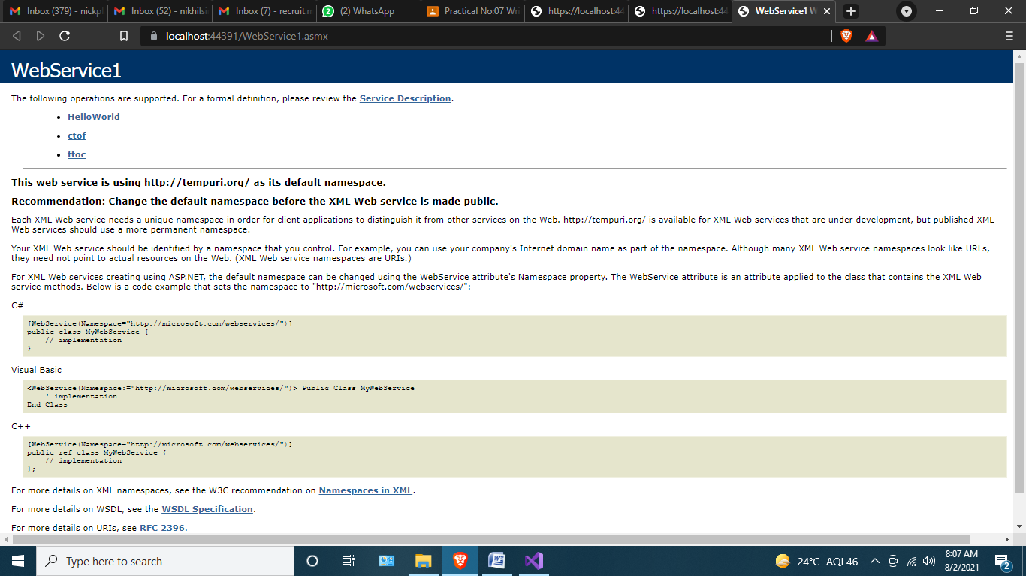

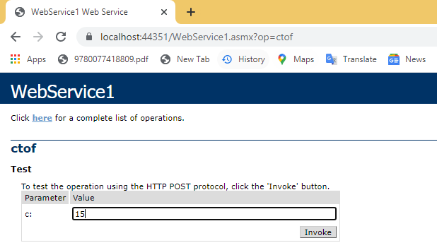

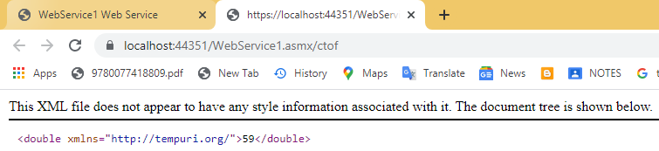

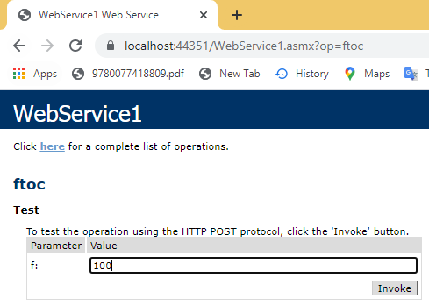

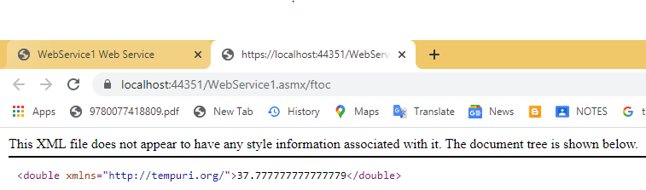

Webform1

using System;

using System.Collections.Generic;

using System.Linq;

using System.Web;

using System.Web.UI;

using System.Web.UI.WebControls;

namespace wspractical1

{

public partial class WebForm1 : System.Web.UI.Page

{

protected void Page_Load(object sender, EventArgs e)

{

}

protected void Button1_Click(object sender, EventArgs e)

{

WebService1 ws = new WebService1();

if (Celcius.Checked)

{

TextBox2.Text = ws.ctof(Convert.ToDouble(TextBox1.Text)).ToString();

}

else if (Fahrenheit.Checked)

{

TextBox2.Text = ws.ftoc(Convert.ToDouble(TextBox1.Text)).ToString();

}

}

}

}

Output:

